Telling your boss why you should go to the 2024 ILEETA Conference & Expo
Dear Chief/Commander/Captain/Lieutenant/Boss,
I would like to attend the 2024 ILEETA Conference, March 18-23, 2024 in St. Louis, MO. This conference is the premier event for law enforcement training featuring more than 140 courses including certifications and armorer courses. The training offered includes many issues currently of concern to our agency such as (list at least 3). AND/OR There are several courses that would enhance my skills and knowledge as a trainer including (list at least 3). (Note any specific training needs the agency may have had or is likely to have including specific incidents or issues.)
The conference includes an Expo of more than 100 vendors of law enforcement products and services. This is an opportunity to speak with experts about new technology and techniques that can make our department more effective and assist in future budget planning. While at the Expo I would intend to meet with the following companies: (list at least three) .
The conference is also an opportunity to network with other trainers and learn from one another how we are meeting today’s challenges to law enforcement. This conference is very cost effective considering the variety of subjects offered over the five and one-half days. In addition to the conference tuition, other costs would include travel, hotel, per diem and (other). I estimate the total of these costs to be: (See detailed breakdown below). I am confident that the return on this investment will be repaid to our department for years to come.
Please examine the 2024 ILEETA Conference & Expo information page https://www.ileeta.org/2024-ileeta-conference-expo/ for more information and thank you for your consideration of this request.
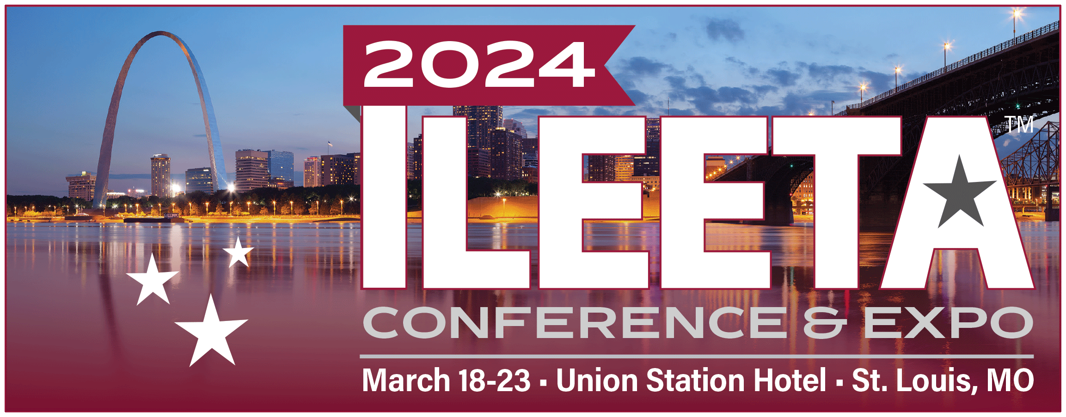
Sincerely, ...

